Experiment:-3
Problem Statement:-
Develop a network simulator using Cisco Packet Tracer to analyze packet delay, loss, and end-to-end throughput. Implement various routing algorithms and measure their impact on network performance under different traffic conditions.
Aim:- Network Simulator for Analyzing Packet Delay, Loss, and Throughput
Procedure:-

PHASE 1: Build the Network

Step 1: Open Packet Tracer
- Click File → New

Step 2: Add Devices to Workspace
Drag and drop devices:-
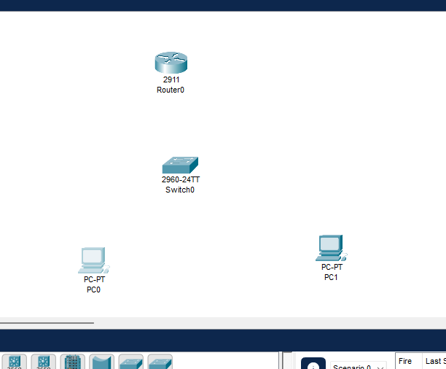

Step 3: Connect Devices with Cables
Use Copper Straight-Through cable:
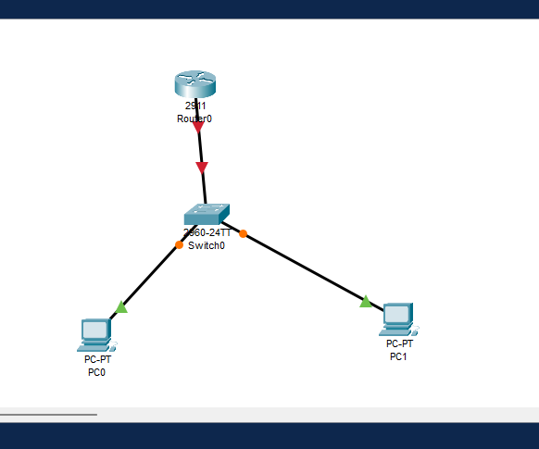

PHASE 2: Configure Router

Step 4: Click Router → CLI tab

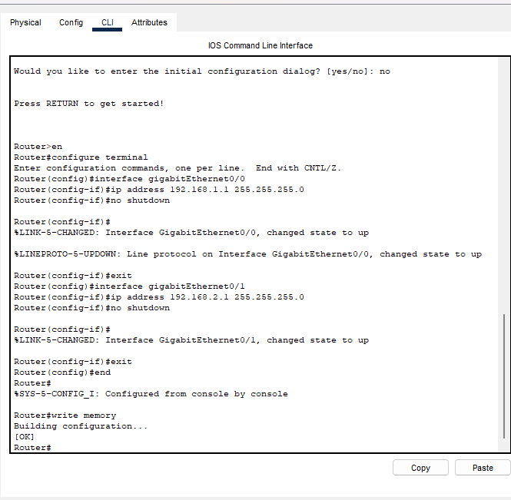
Step 5: Verify Router
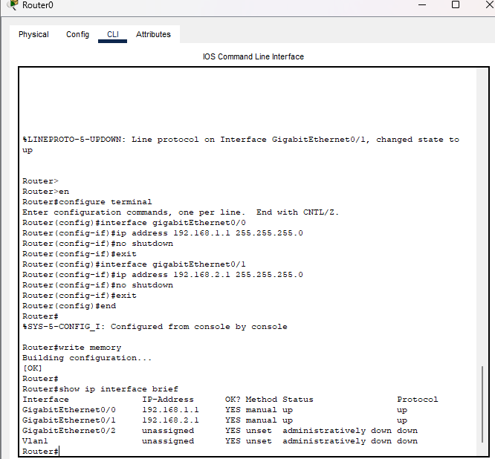

PHASE 3: Configure PCs

Step 6: Click each PC → Desktop → IP Configuration

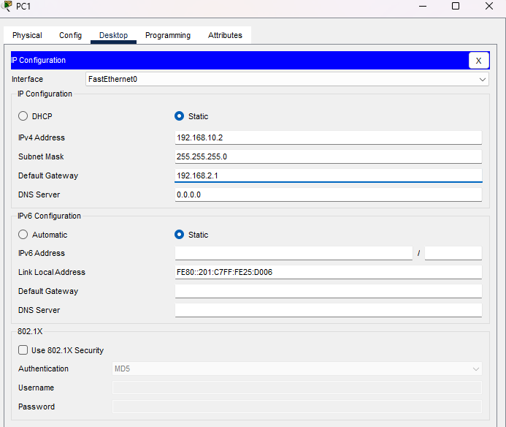

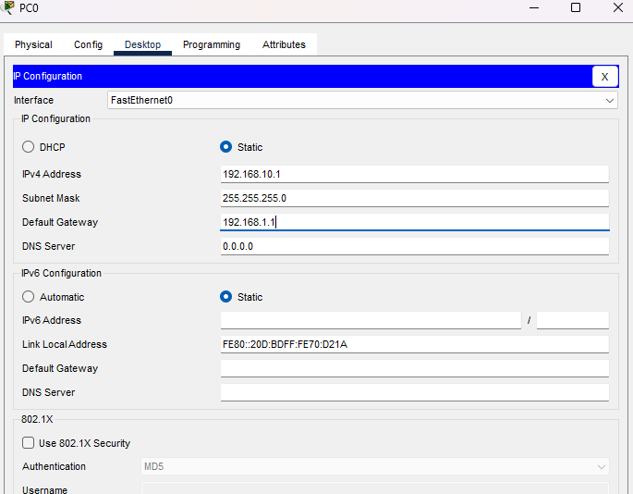

PHASE 4: Static Routing

Step 7: Add Static Routes on Router

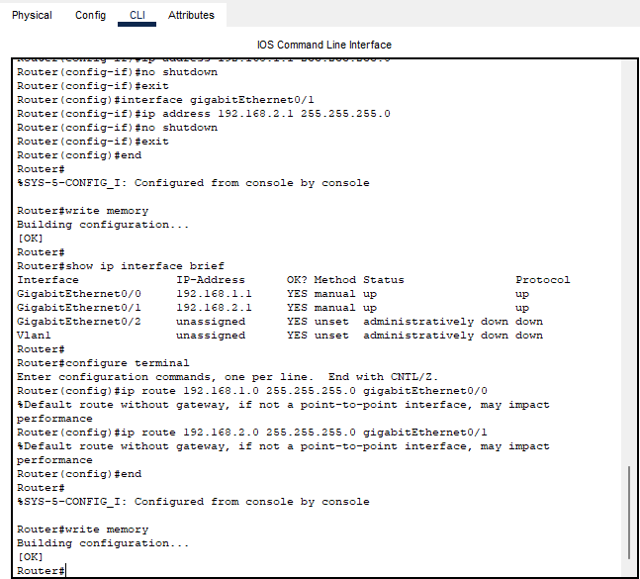

PHASE 5: Test Connectivity

Step 8: Ping from PC0
- Click PC0 → Desktop → Command Prompt
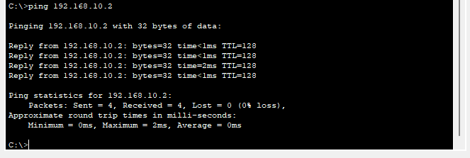

PHASE 6: Simulate Traffic

Step 9: Use Add Simple PDU
- Click the envelope icon (Add Simple PDU) in the toolbar
- Click PC0 then click PC1
- A packet will appear on the workspace
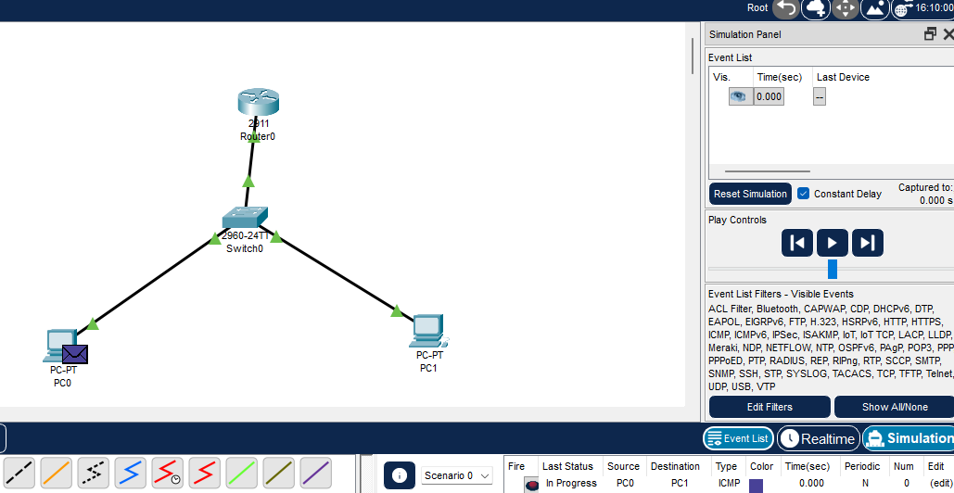

Step 10: Switch to Simulation Mode
- Click Simulation tab (bottom right)
- Press Play or Step button
- Watch packets travel PC0 → Switch0 → Router → Switch1 → PC1
